Healer (치료자)

A D E A
You hold my every moment, You calm my raging sea
주 모든 삶 붙드사 날 잠잠 -케 하네
A /G# F#m7 D Esus E
You walk with me through fire, And heal all my disease
주 나와 함께 -하며 내 상처 치유해
Bm7 A/C#-D Bm7 D E
I trust in You, I trust in You
주 신 -뢰 -해 주 신 -뢰 -해

A
I believe You're my Healer
난 믿네 내 치료자
F#m7 E D E F#m7 E/G#
I believe You are all I need
난 믿네, 주 내 모든 것
A
I believe You're my Portion
난 믿네, 주 내 기업
F#m7 Esus4 D E
I believe You’re more than enough for me
난 믿네, 내게 부족함 없는
F#m7 E/G# D E F#m7 E/G#
Jesus You're all I need
예수 내 모든 것

F#m7 E/G# Asus A F#m7
Nothing is impossible for You
능치 못함 없으리 주께
E/G# Asus A
Nothing is impossible
능치 못함 없으리
F#m7 E/G# Asus A/C# D
Nothing is impossible for You
능치 못함 없으리 주께
F#m7 E
You hold my world in Your hands
주의 손 날 붙드네
Used by Permission. CCLI #11103902 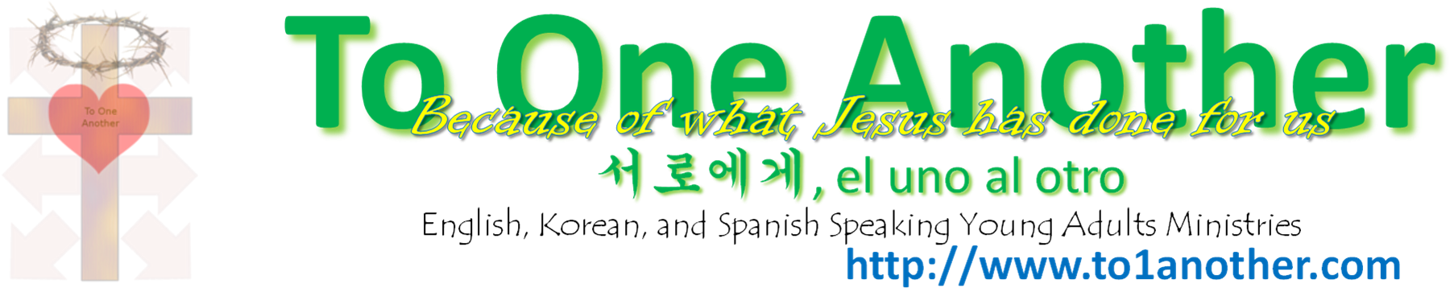
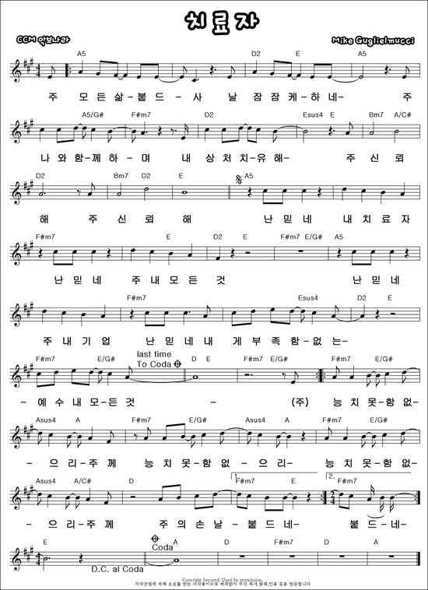
Used by Permission. CCLI #11103902

